With draining

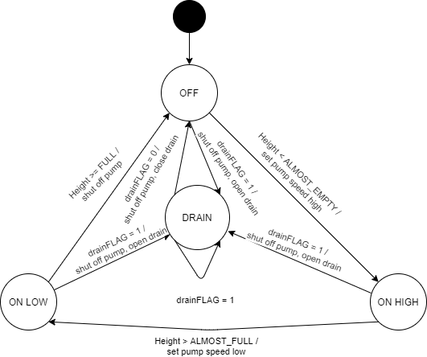

The changes I made to facilitate the new state diagram is that I added a global flag to connect the drainflag between the files, as well as adding the new transitions into both the state diagram and the switch statements within the pump. I also added prompts, both to start the draining process and to stop it once it has started.